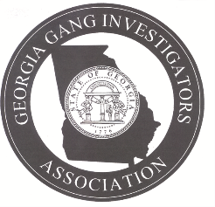 Georgia Gang Investigators Association
Subject: GGIA Intermediate Street Gang Investigator Certification Course
The Board of Directors of the Georgia Gang Investigators Association (GGIA) has approved the implementation of an Intermediate Street Gang Investigator Certification for its members. The certification course will be held at 8:00 a.m. on Monday, July 8, 2024, at the Classic Center, Athens, GA. 30601.
Personnel applying to obtain a GGIA Intermediate Street Gang Investigator Certification must meet the following criteria:
- Be a current member in good standing of the Georgia Gang Investigators Association
- Have successfully completed the qualifications for the GGIA BASIC Street Gang Investigators Certification Course
- Pay a tuition cost of $100.00 (Add $5.00 processing fee for credit card payment)
- Attend the entire 8 -hour GGIA Intermediate Street Gang Investigator Certification Course
- Successfully pass the Intermediate Street Gang Investigator Certification test with minimum score of 70%
Intermediate Street Gang Investigator Certification Applicant

____________________________________________ _________________________
Applicant Full Name and Rank Date
____________________________________________________________________________________
Applicant Agency and Street Address
_____________________________________________ _________________________
Applicant City, State and Zip Code Okey Number
_____________________________________________ _________________________
Email address Payment Amt. - Received By
_____________________________________________ _________________________
Location of GGIA Basic Certification Course Date of Course

Please fill out the above application and submit with $100.00 check or money order to: GGIA, P.O. Box 2949, Richmond Hill, GA 31324.

All participants are required to bring a laptop to the training to complete the course work and required reading material will be sent out prior to the training date.

