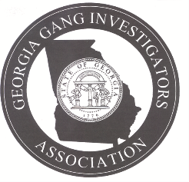 Georgia Gang Investigators Association

Subject: GGIA Basic Street Gang Investigator Certification Course
The Board of Directors of the Georgia Gang Investigators Association (GGIA) has approved the implementation of a Street Gang Investigator Certification for its members. The certification course will be held at 8:00 a.m. on Tuesday, March 28, 2023, at the Gwinnett County Police Department Training Center located at 854 Winder Road, Lawrenceville, GA. 30045.

Personnel applying to obtain a GGIA Basic Street Gang Investigator Certification must meet the following criteria:
- Be a current member in good standing of the Georgia Gang Investigators Association
- Pay a tuition cost of $100.00 (Add $5.00 processing fee for credit card payment)
- Attend the entire 8-hour GGIA Basic Street Gang Investigator Certification Course
- Successfully pass the Basic Street Gang Investigator Certification test with minimum score of 70%
Basic Street Gang Investigator Certification Applicant

____________________________________________ _________________________
Applicant Full Name and Rank Date
____________________________________________________________________________________
Applicant Agency and Street Address
_____________________________________________ _________________________
Applicant City, State and Zip Code Okey Number
_____________________________________________ _________________________
Email Address Payment Amt. - Received By
_____________________________________________ _________________________
Location of GGIA Basic Certification Course Date of Course

Please fill out the above application and submit with $100.00 check or money order to: GGIA, P.O. Box 2949, Richmond Hill, GA 31324.

